REVERSE CAR PARKING ASSISTANCE SYSTEM

A Reverse Car Parking Assistance System is designed to help drivers park their vehicles safely by detecting obstacles behind the car using ultrasonic sensors, cameras, or radar technology. It improves safety, convenience, and precision while reversing.
A Reverse Car Parking Assistance System significantly reduces parking-related accidents, enhances convenience, and provides a stress-free driving experience. It is a valuable addition to modern vehicles, improving both safety and efficiency.

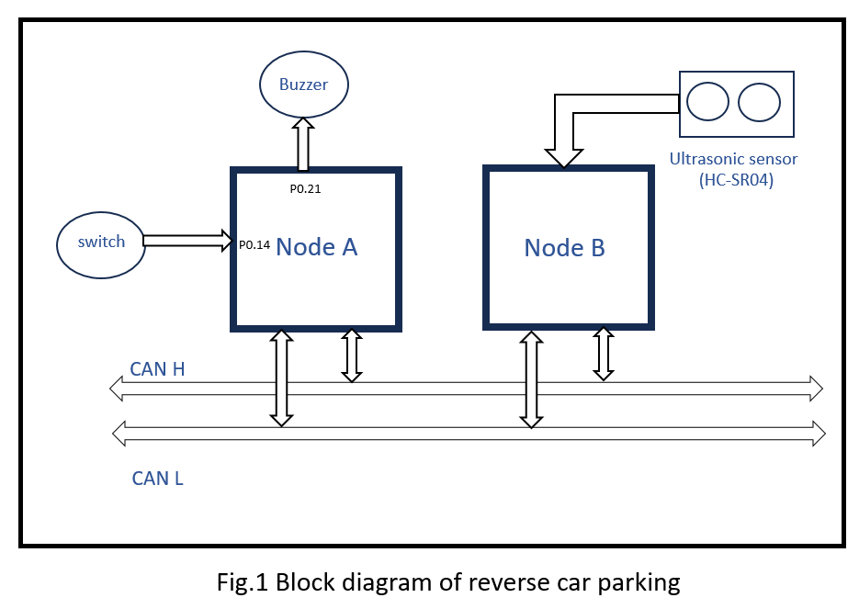

COMPONENTS USED:
NAME OF THE COMPONENTS | NUMBERS USED
Vector boards | 2
Switch | 1
Ultrasonic sensor (HC-SR04) | 1
Buzzer | 1

DESCRIPTION:
Ultrasonic sensor:
The HC-SR04 is a widely used ultrasonic distance sensor that measures the distance to an object using ultrasonic waves. It is commonly used in robotics, obstacle avoidance systems, and home automation projects.

SPECIFICATIONS:
- Frequency: 40kHz
- Measuring Range: 2 cm to 400 cm
- Operating voltage: 5V DC

PINCONFIGURATION:
Pin no | Name | Description
Any VCC pin | VCC | Power supply (5V)
Any GPIO pin | Trig | Trigger input (initiates measurement)
Any GPIO | Echo | Echo output (returns pulse width)
Any GND pin | GND | Ground
Table number 1. Ultrasonic sensor pin configuration

WORKING PRINCIPLE:
- Triggering the Sensor:
- A 10us HIGH pulse is sent to the Trig pin.
- This initiates an ultrasonic pulse (40kHz).
- Echo Reception:
- The pulse reflects off an object and returns to the Echo pin.
- The sensor outputs a HIGH pulse whose duration is proportional to the distance.
- Distance Calculation:
- The time duration (T) of the echo pulse is measured.
- Distance (cm) = (T × Speed of Sound) / 2
= (T × 0.0343) / 2

